Computer Science 311: Artificial Intelligence - Assignment 1: Developing a Machine Learning App
Elizaveta Skomorokhova
30 Apr 2026
Sugarmark: Machine Learning App for Sugar Price Prediction
1. Name and Purpose of the App
Sugarmark forecasts the price for sugar 5 days into the future by using machine learning to analyse historical market data from 2015 to the present day.
2. Algorithms Used
The app uses the RandomForestRegressor function from scikit that “fits a number of decision tree regressors on various sub-samples of the dataset and uses averaging to improve the predictive accuracy and control over-fitting” (Scikit-learn developers, n.d.). I chose this algorithm for its robustness; because it is an ensemble method, and the aggregation of different predictions “helps smooth out the individual errors of each tree, resulting in more stable and accurate predictions” (Shaji, A. S. K., 2025)
3. Dataset Information
- 3.1 Dataset source/link
Dataset: Yahoo Finance Sugar #11 futures
Ticker: `SB=F`
Dataset link: https://finance.yahoo.com/quote/SB%3DF/
- 3.2 Number of records
2,851 (trading days of sugar price data)
- 3.3 Number of features
The app takes ‘Closing’ price for sugar from the dataset, and also creates the following 4 features.
- 3.4 Description of features: Feature Name, Description, Data Type
1) price_yesterday
The sugar closing price from the previous day, float.
2) price_5_days_ago
The sugar closing price from 5 days ago, float.
3) average_price_5_days
The average sugar closing price over the last 5 days, float.
4) average_price_20_days
The average sugar closing price over the last 20 days, float.
- 3.5 Preprocessing steps (e.g., cleaning or normalization)
The original dataset has many columns. During the processing step, only “Date” and “Close” data are saved. Then data is sorted by date to ensure current order, and empty rows are removed. Then, the 4 features above are created out of the original “Close” data, as well as a column for target data (sugar price 5 days in the future); empty rows are once again removed.
4. Libraries, Toolkits, and Frameworks
- List all libraries used (e.g., Pandas, NumPy, Scikit-learn) and explain their roles.
The project Pandas, Yfinance, Scikit-learn (ensemble and metrics) libraries. Pandas loads the csv data and is used for data cleaning and creation of features. Yfinance downloads sugar price data from Yahoo Finance. Scikit-learn provides functionality for the machine learning algorithm: RandomForestRegressor, as well as evaluation metrics.
5. Application Design and Implementation
- Describe how the app works, including data flow, model training, and prediction.
The app downloads data for Sugar Future Prices from Yahoo Finance and saves “Close” data into a dataset simple_sugar_prices.csv. It creates 4 feature columns: yesterday’s price, price 5 days ago, 5-day average price, 20-day average price and the target column: sugar price 5 trading days in the future. The model uses RandomForestRegressor to learn from past sugar prices and predicts the sugar price 5 trading days later. It is trained on 80 percent on the data, then tested on 20 percent of the remaining data. Mean Absolute Error, Root Mean Square Error and R2 Score are used to evaluate the accuracy of the model. For prediction, the app downloads the latest data using Yfinance and displays the prediction.
6. Instructions for Running the App
- Provide a step-by-step guide on how to execute the code. Include environment setup or dependencies.
To run the code, one needs to have Python 3.11.5, as well as Pandas 2.3.3, yfinance 0.2.66 and Scikit-learn 1.3.0 installed. The easiest way to start the program is to download it onto your computer, open simple_sugar_predictor.py in Visual Code Studio and click “Run”. The alternative would be to run terminal, then enter cd [path_to_file], for example: cd /Users/username/Downloads/sugar-price-predictor-using-random-forest, then python simple_sugar_predictor.py or python3 simple_sugar_predictor.py.
7. Results
- Include screenshots that demonstrate the app in operation and display the prediction results.
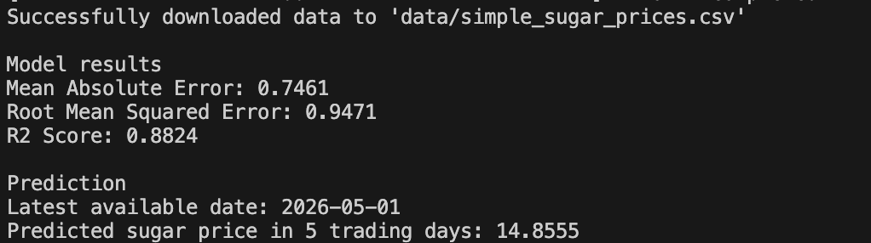
8. Discussion and Insights
- The model is limited to training on financial data. It would be better to include weather data, political news (using NLP) and other factors that affect the price of sugar in the machine learning algorithm. This is a working app in theory, but in practice, I would not bet my money on the predictions it makes, as the logic design is too simplistic.
9. References:
1. Scikit-learn developers. (n.d.). RandomForestRegressor. Scikit-learn. https://scikit-learn.org/stable/modules/generated/sklearn.ensemble.RandomForestRegressor.html
2. Shaji, A. S. K. (2025). Decision trees & random forests: Algorithms for pattern recognition & prediction. Study.com. https://study.com/academy/lesson/decision-trees-random-forests-algorithms-for-pattern-recognition-prediction.html

